Program 1

n=int(input("Enter limit"))

f=1

for i in range(1,n+1):

f=f*i

print("Factorial of" ,n,'=',f)

Output:

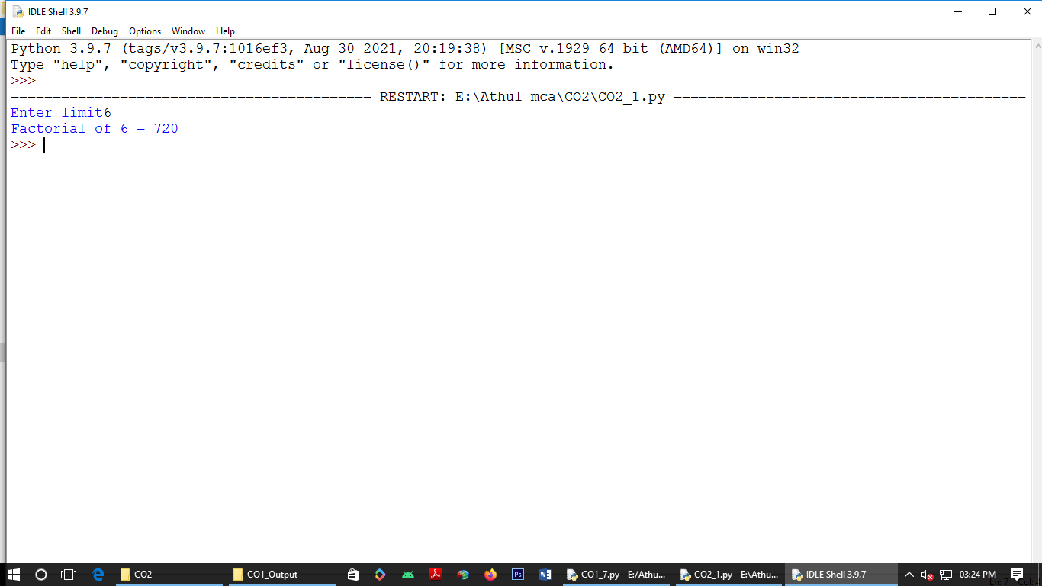

Program 2

n=int(input("Enter limit:"))

a=0

b=1

sum=0

count=1

print("fibo:",end=" ")

while(count<=n):

print(sum,end=" ")

count+=1

a=b

b=sum

sum=a+b

Output:

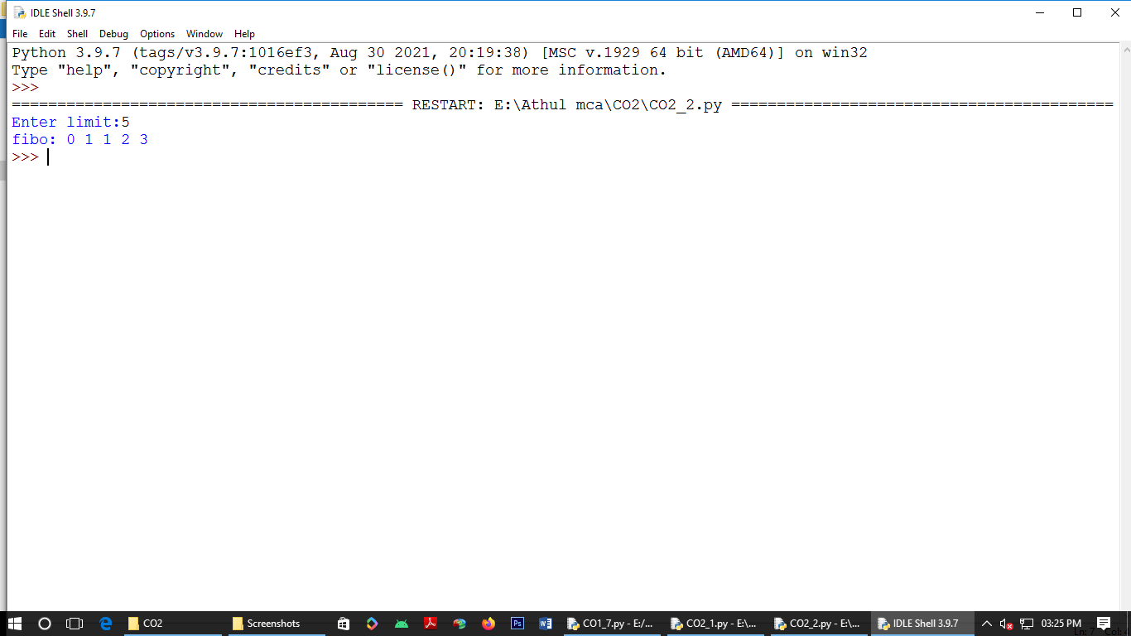

Program 3:

list1=[10,15,20,25,30]

print("Numbers in list:",list1)

total=sum(list1)

print("Sum=",total)

Output

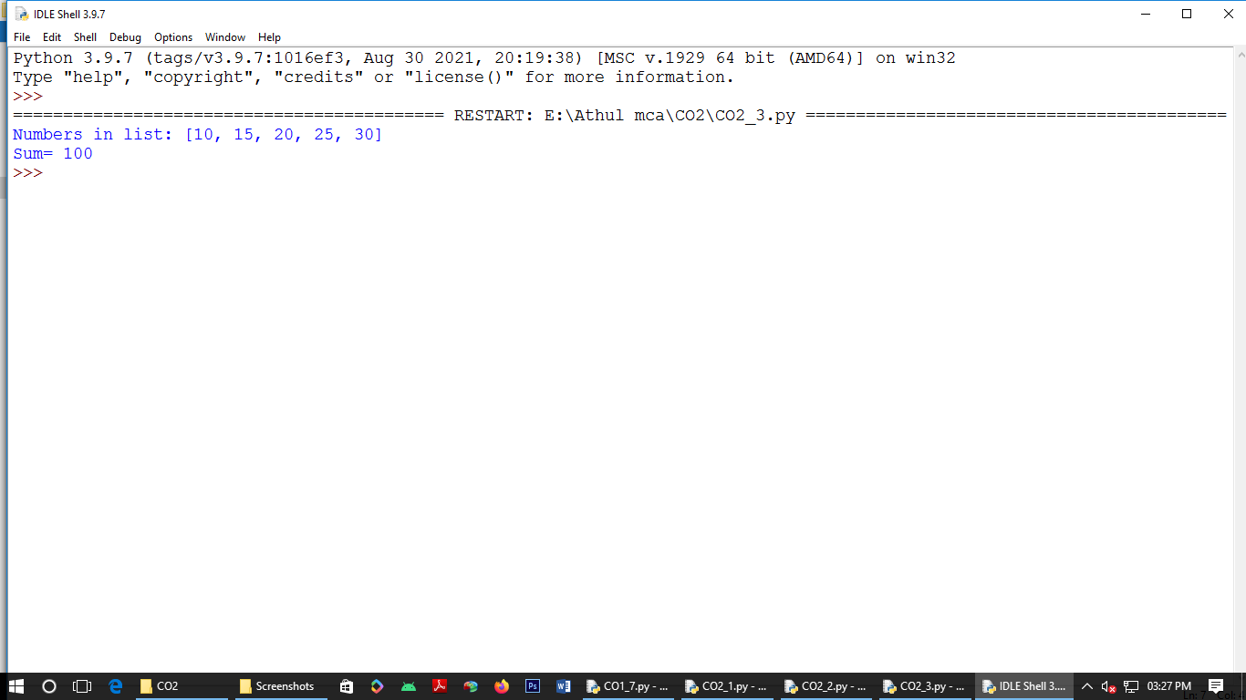

Program 4

from math import sqrt as s

for i in range(1000,10000):

if s(i)==int(s(i)) and i%2==0:

print(i,end=" ")

Output:

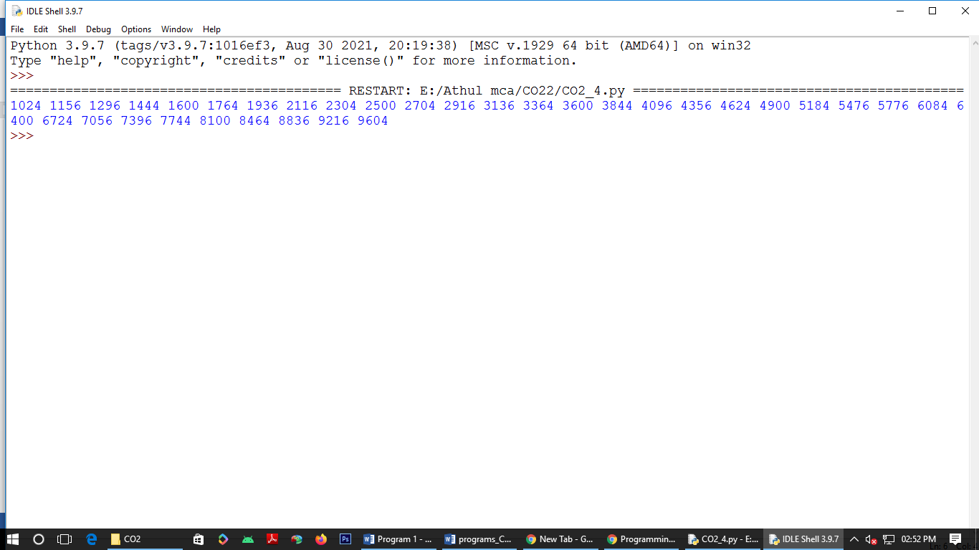

Program 5

rows=int(input("Enter Nm of rows:"))

for i in range(1,rows+1):

for j in range(1,i+1):

print(i*j,end=" ")

print()

Output:

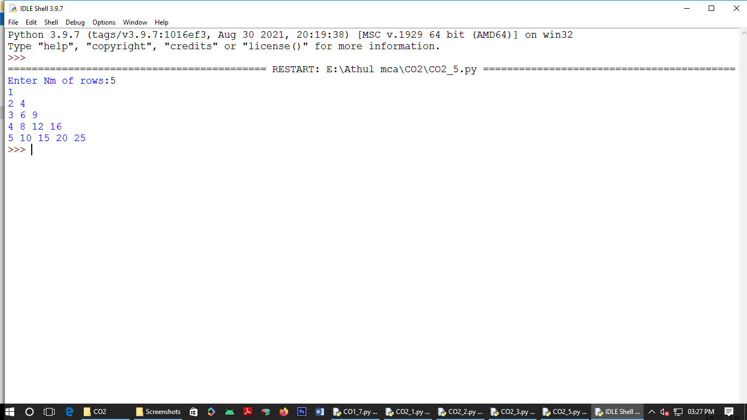

Program 6

test_str=str(input("Enter the string:"))

freq={}

for i in test_str:

if i in freq:

freq[i]+=1

else:

freq[i]=1

print("Count ="+str(freq))

Output:

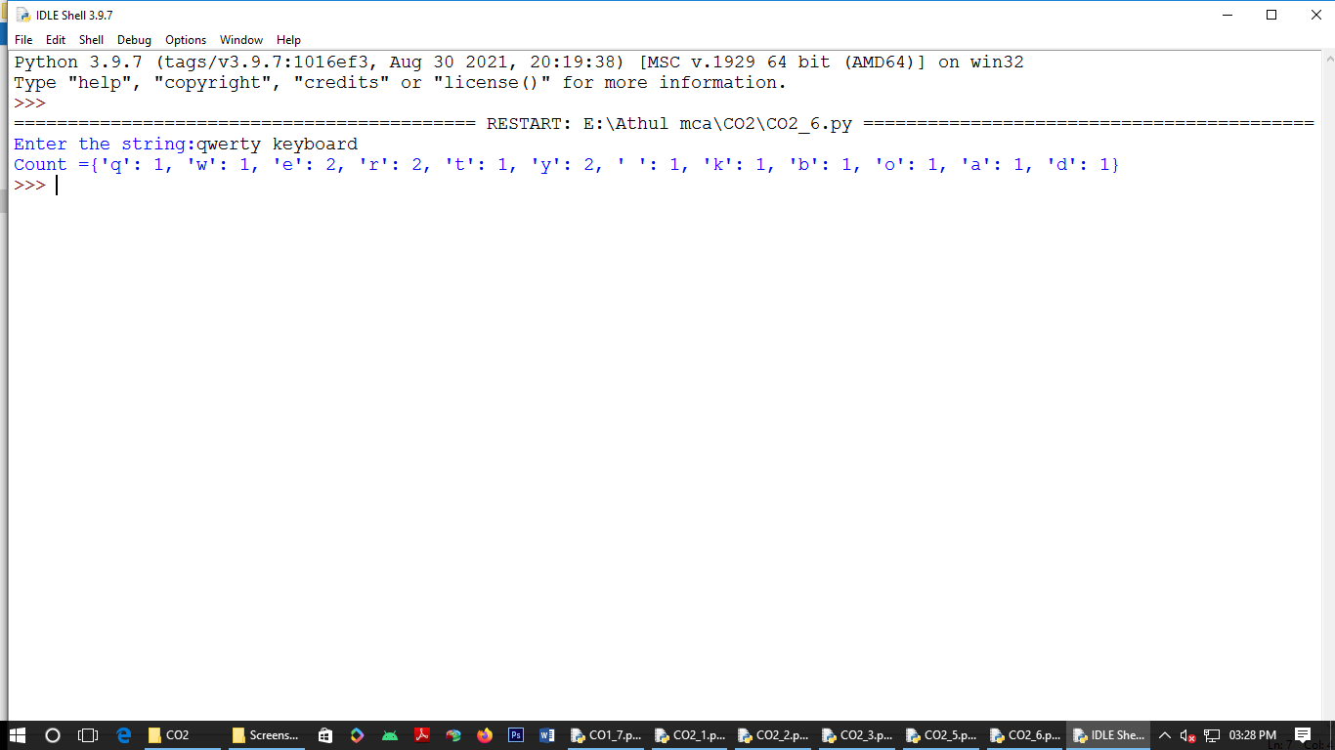

Program 7

str=input("input string:")

print("Entered string:",str)

if(str.endswith("ing")):

str=str+'ly'

else:

str=str+'ing'

print("format string:",str)

Output:

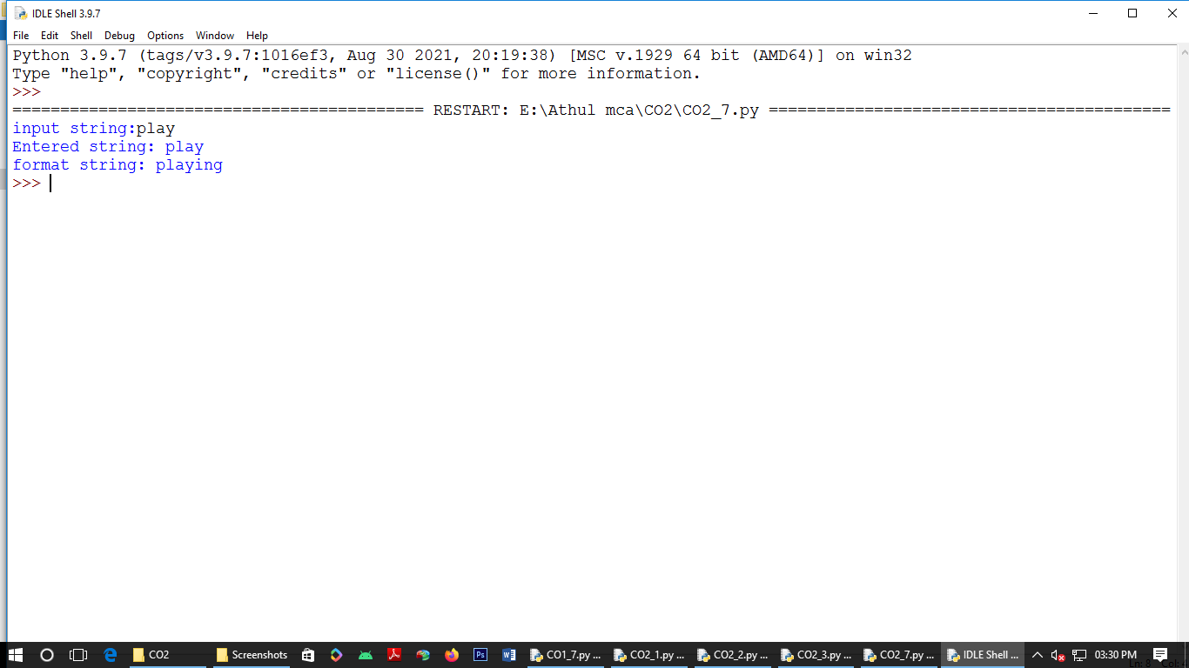

Program 8

a=[]

n=int(input("Enter limit:"))

for i in range(0,n):

element=input("Enter element:"+str(i+1))

a.append(element)

max1=len(a[0])

temp=a[0]

for j in a:

if(len(j)>max1):

max1=len(j)

temp=j

print("Longest Word:",temp)

print("Length:",max1)

Output:

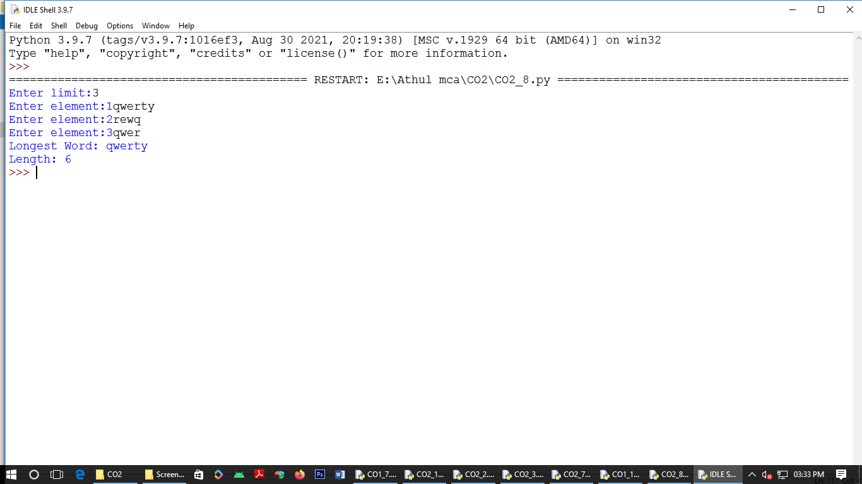

Program 9

n=int(input("Enter limit:"))

for i in range(n):

for j in range(i):

print("*",end=" ")

print()

for i in range(n,0,-1):

for j in range(i):

print("*",end=" ")

print()

Output:

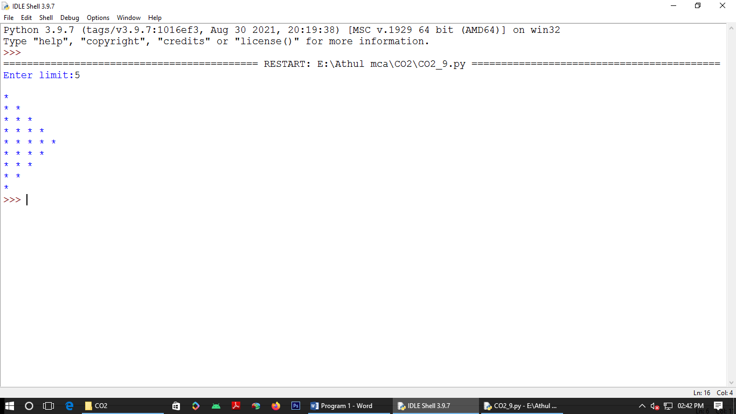

Program 10

def factor(x):

print("Factors of",x,"are:")

for i in range(1,x+1):

if x%i==0:

print(i)

n=int(input("Enter limit:"))

factor(n)

Output:

